**Docker Hub**

1. **Signup on dockerhub.**
2. **Login on dockerhub and create a repository by providing repo name "mytestrepo" and a little description about the same.  
   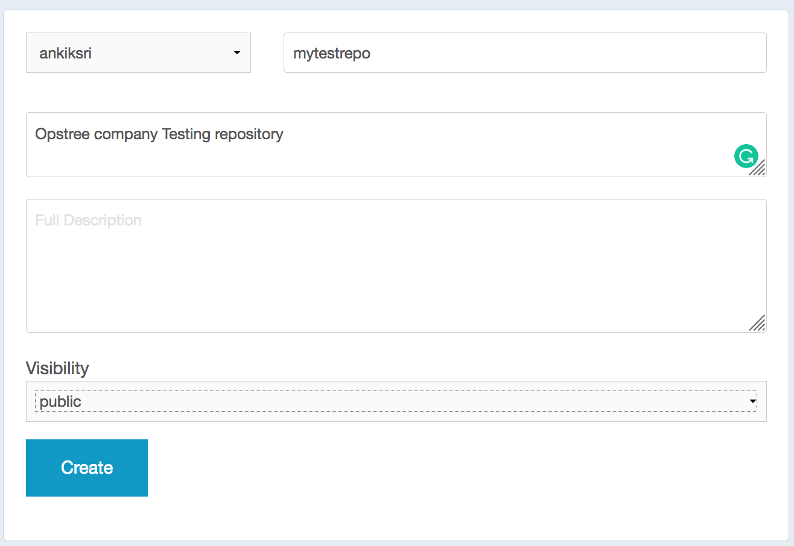**
3. Search for "centos" image on docker using commandline.  
   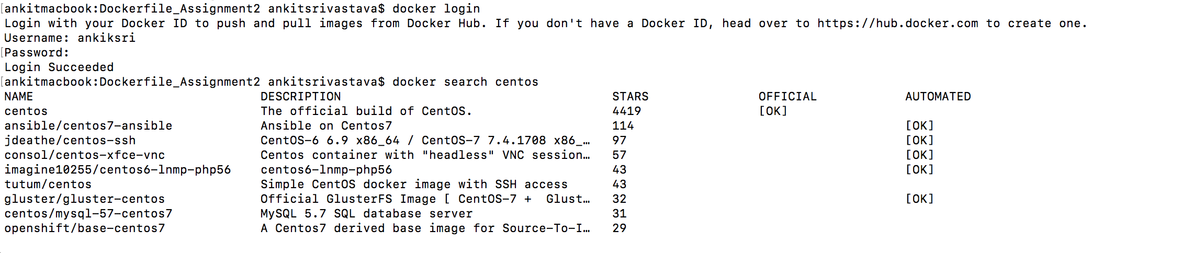
4. Limit out search result to 10 entries only  
   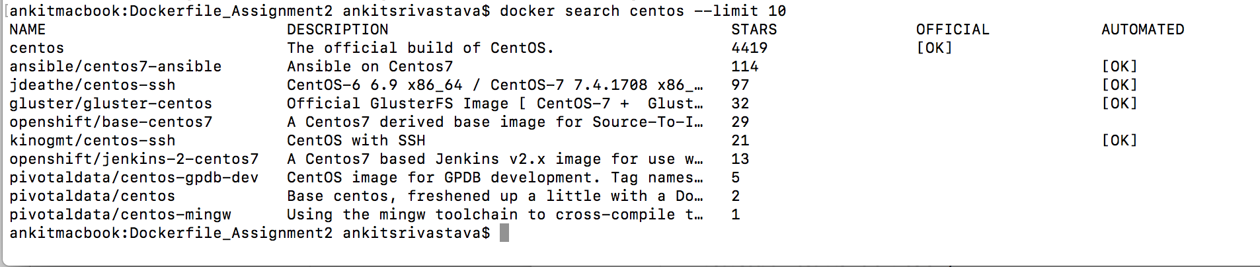
5. Apply a filter on search result to show entries for images having 3 stars.  
   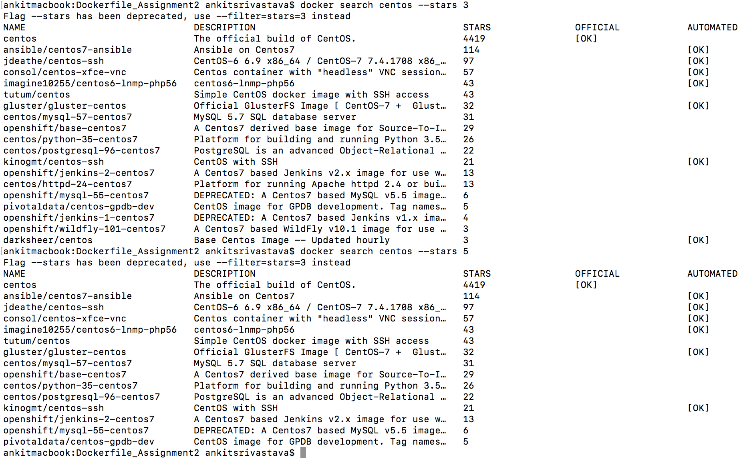
6. Format the search result to get output containing only name,description and is_official values  
   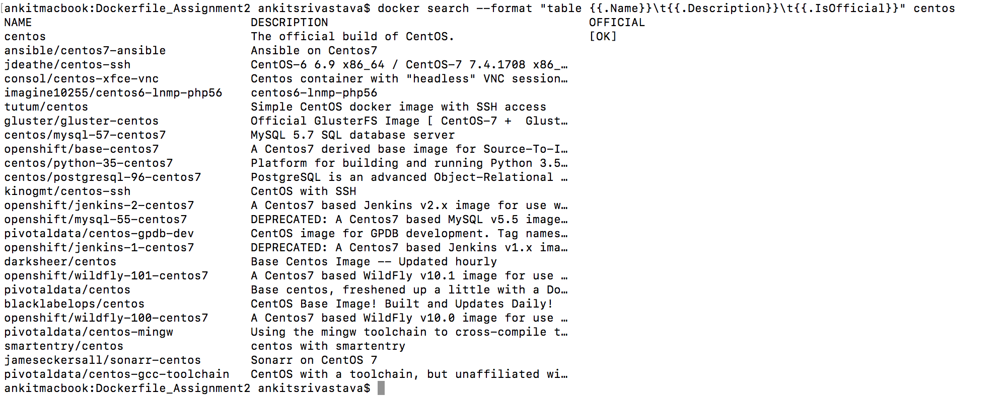
7. Pull an image named "centos" from dockerhub.  
   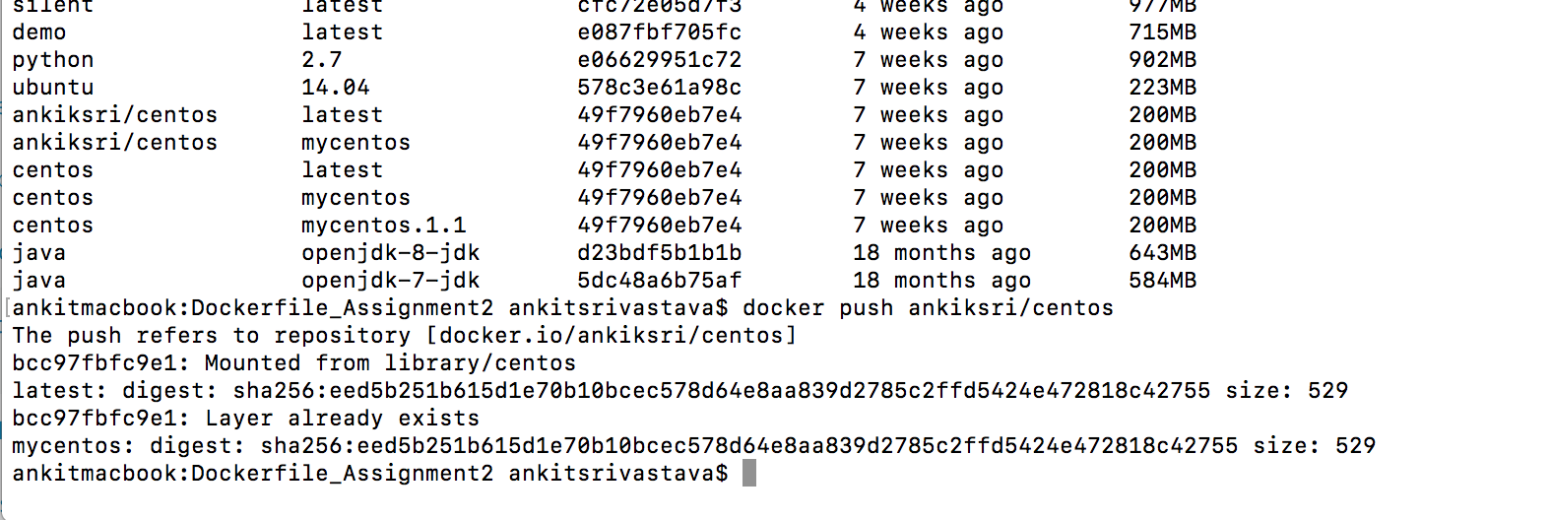  
   
8. Do commandline logout on dockerhub.  
   